Assignment -1

Python Programming

|  |  |
| --- | --- |
| Assignment Date | 18-10-2022 |
| Student Name | AJITHA K M |
| Student Roll Number | 111519104004 |
| Maximum Marks |  |

**Question 1:**

**Import the necessary libraries**

Solution:

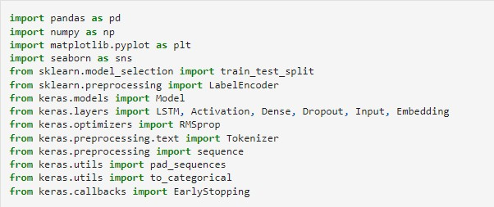

**Question 2:**

**Download the Dataset**

Solution:

Dataset Downloaded and uploaded to drive [https://www.kaggle.com/code/kredy10/simple-lstm-for-text-](https://www.kaggle.com/code/kredy10/simple-lstm-for-text-classification/data) [classification/data](https://www.kaggle.com/code/kredy10/simple-lstm-for-text-classification/data)

**Question 3:**

**Read dataset and do pre-processing**

Solution: Read dataset

C:\Users\Welcome\Pictures\Screenshots\Screenshot (54).png

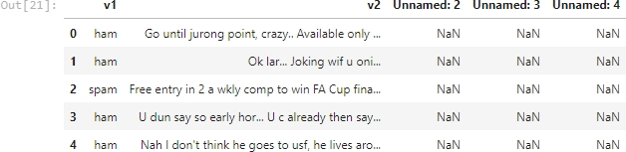

Pre-processing the Dataset

